**RV UNIVERSITY**

**School of Computer Science and Engineering**

**Bengaluru – 560059**

**Linux Administration**

**Course Code: CS1106**

**II Semester SoCSE**

**Laboratory Record**

|  |  |
| --- | --- |
| **Name** | **AKANKSHA** |
| **USN** | **1RUA24BCA0004** |
| **Academic Year** | **2024 - 2025** |

**RV UNIVERSITY**

**School of Computer Science and Engineering**

## Bengaluru – 560 059

**LABORATORY CERTIFICATE**

This is to certify that **Mr./Ms.** AKANKSHA has satisfactorily completed the course of activities in **Linux Administration (CS)** prescribed by the **School of Computer Science and Engineering** during the year **2024-25.**

**Name of the Candidate: AKANKSHA**

**USN: 1RUA24BCA0004**

**Semester: 2nd**

|  |  |
| --- | --- |
| **Marks** | |
| **Maximum** | **Obtained** |
| **5** |  |

**Signature of Faculty in-charge Program Director**

**Date:**

## Vision and Mission of the School of Computer Science and Engineering

## Vision

## To be a pioneering school of Computer Science and Engineering committed to fostering

## liberal education and empowering the next generation of technologists to make a positive

## global socio-economic impact.

## Mission

## To be a pioneer in computer science education and benchmark ourselves with the world's top computer science and engineering institutions.

## To provide state-of-the-art facilities that enable exemplary pedagogy, advanced research, innovation and entrepreneurship in emerging technologies of computer science.

## To promote a culture of cooperation and inclusiveness among students and faculty from diverse communities enabling them to take part in interdisciplinary and multidisciplinary research, contributing to institution-building.

## To foster excellence through national and international academic, industry collaborations, bringing in diverse perspectives to drive innovation.

## To nurture a talented pool of ethical, self-driven and empathetic problem solvers to achieve sustainable development goals.

### INDEX

|  |  |  |  |
| --- | --- | --- | --- |
| **Sl.**  **No** | **Program Name.** | **Date** | **Page No.** |
| 1 | Basic Linux Navigation | 30/01/2025 | 5 |
| 2 | Using the vi/vim editor | 13/02/2025 | 8 |
| 3 | Exploring the Directory Structure and File Types | 27/02/2025 | 10 |
| 4 | Creating and Managing User Accounts | 05/03/2025 | 12 |
| 5 | Writing Basic Shell Scripts | 06/03/2025 | 14 |
| 6 | Mounting and Formatting USB Drives | 20/03/2025 | 15 |
| 7 | Backing Up and Compressing Files | 28/03/2025 | 17 |
| 8 | Managing User and Group Permissions and Communication Utilities | 28/03/2025 | 19 |
| 9 | Process Management | 03/04/2025 | 20 |
| 10 | Disk Space Management | 03/04/2025 | 22 |

**Lab 1: Basic Linux Navigation**

**Aim: Learn to use the command line programs to navigate and manage a linux system**

**Commands used:**

* ls
* cd
* pwd
* touch
* mkdir
* rmdir
* rm
* mv
* cp

**Usage:**

1. ls – list directory contents

Syntax: ls [options] [directory]

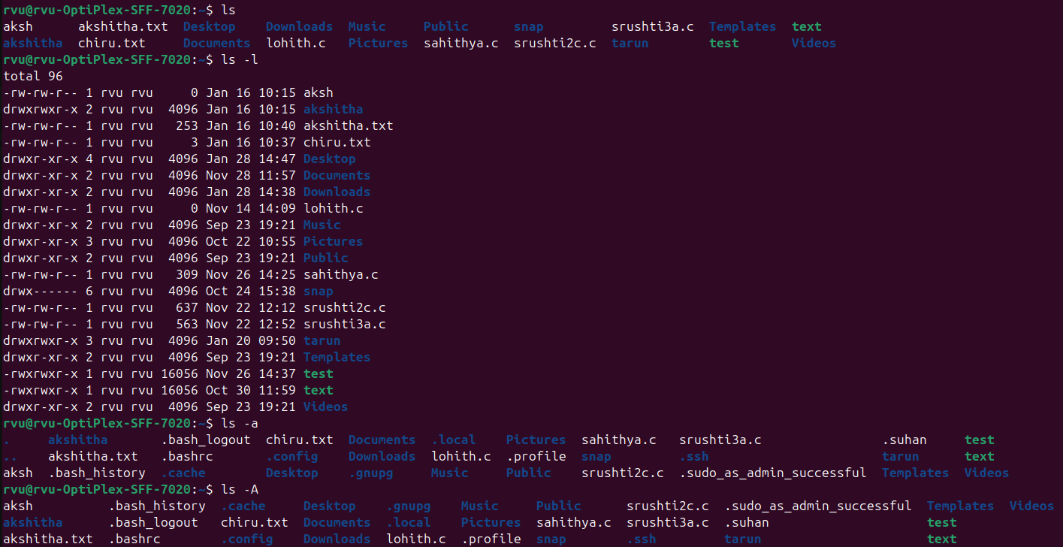

1. cd – change directory

Syntax: cd [directory]

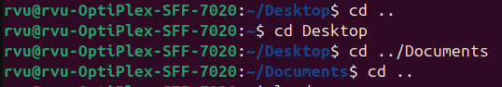

1. pwd –print working directory

Syntax: pwd



1. touch –Creates empty file

Syntax: touch [filename]

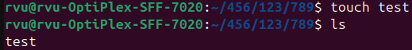

1. mkdir –creates new directory

Syntax: mkdir [directory_name]

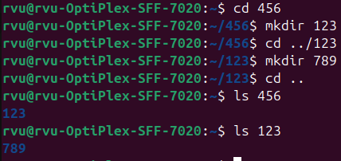

1. rmdir –deletes an empty directory

Syntax: rmdir [directory_name]

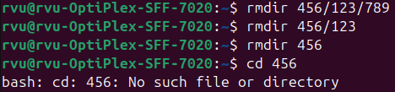

1. rm –deletes files/directories

Syntax: rm [file_name]

rm -r [directory_name]

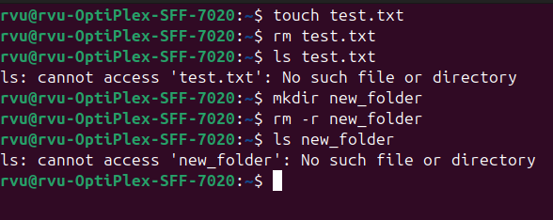

1. mv –move or rename files & directories

Syntax: mv [source] [destination]

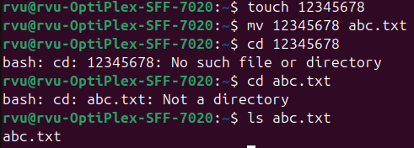

1. cp –copies files/directories

Syntax: cp [source] [destination]

cp -r [source_directory] [destination_directory]

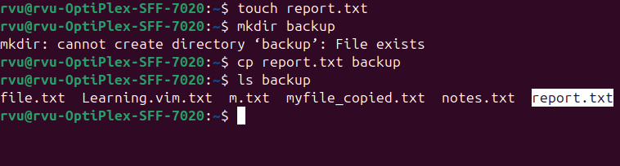

**Lab 2: Using the vi/vim editor**

**Aim: Learn to use the text-based editor vim.**

**Commands used:**

* vimtutor
* vim

**Usage:**

1. vimtutor – learn how to use the vim editor

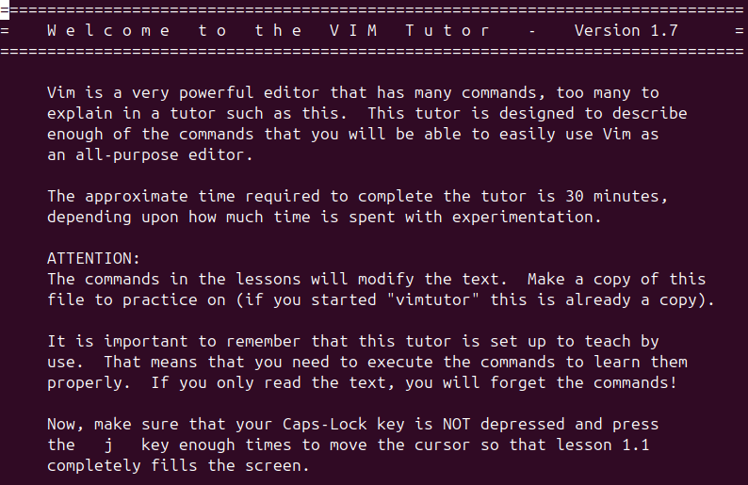

1. vim

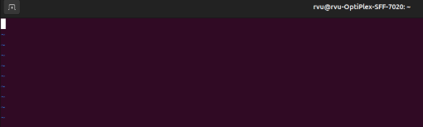

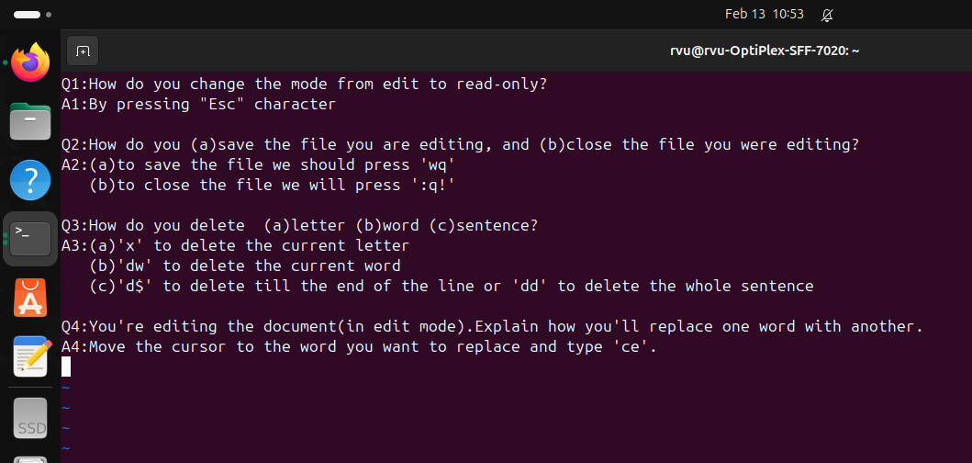

**Lab 3:**

**Aim: Exploring the Directory Structure and File Types**

**Commands used:**

* ls /
* ls /home
* ls /bin
* ls /etc

**Usage:**

1. ls / [Root directory]



2. ls /home [User home directories]



3. ls /bin [Essential user binaries]

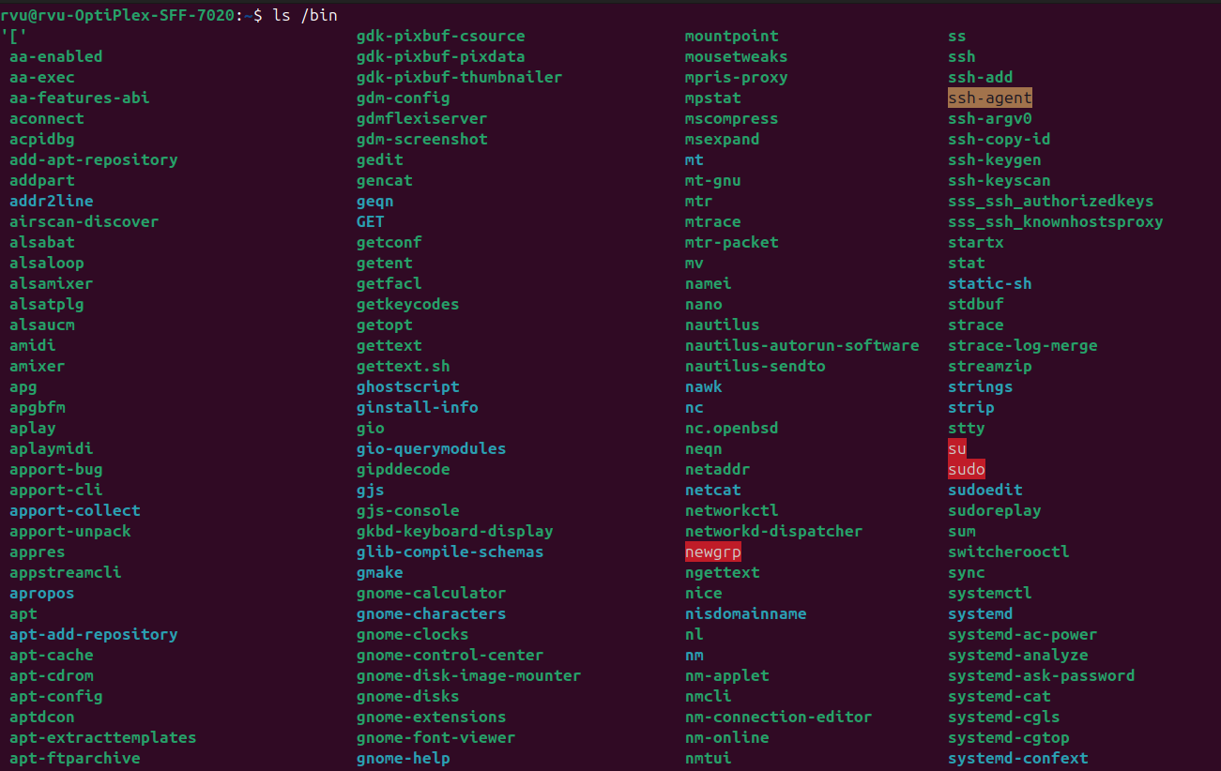

4. ls /etc [Configuration files]

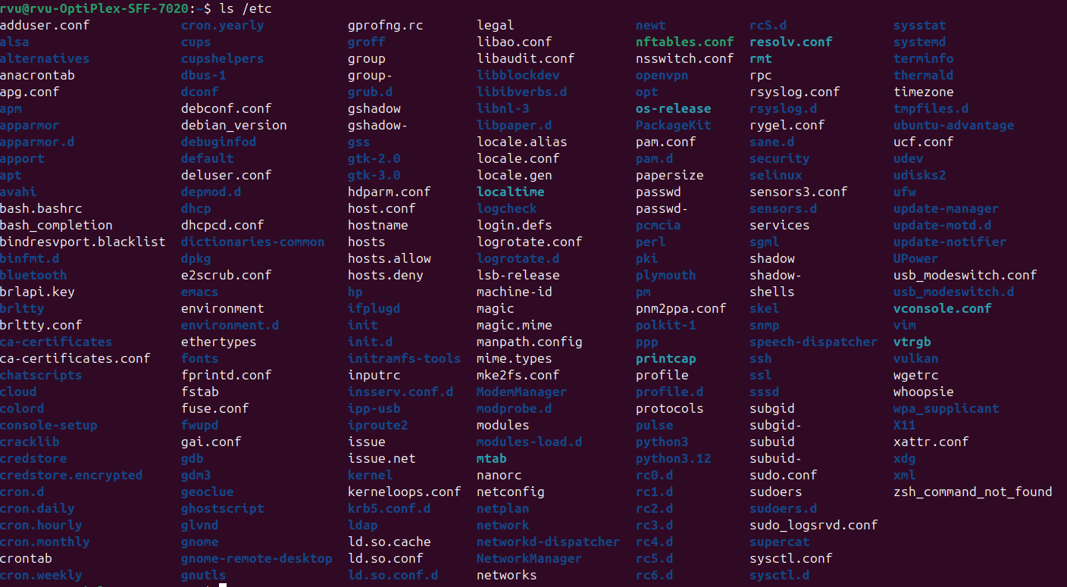

5. ls /var [Variable datalogs]

|  |
| --- |
|  |

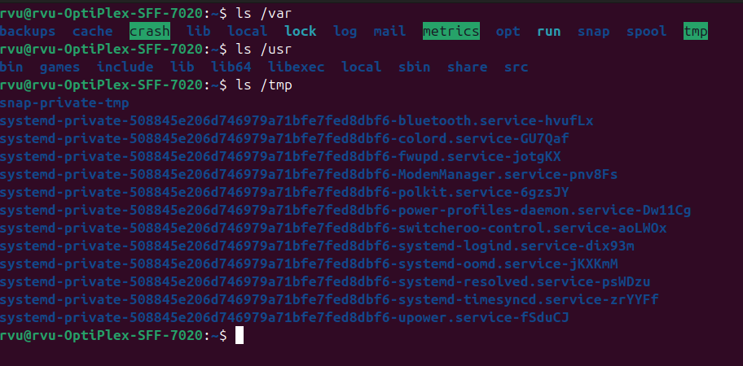

**Lab 4:**

**Aim: Creating and Managing User Accounts**

**Commands used:**

* sudo adduser username
* sudo passwd username
* cat /etc/passwd
* sudo deluser username

**Usage:**

1. sudo adduser username -creates a new user

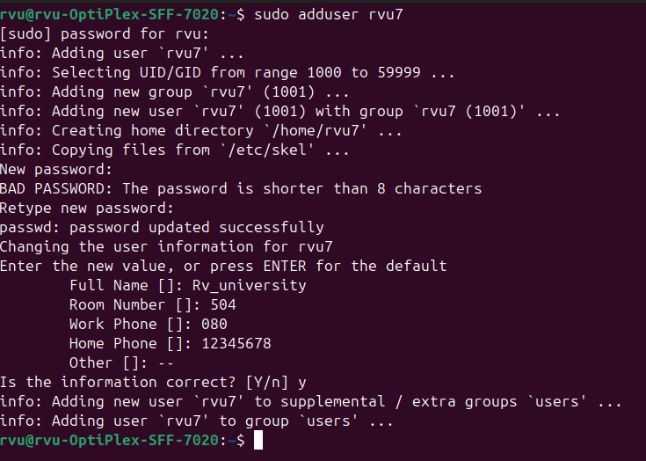

2. sudo passwd username **- set or change the password**

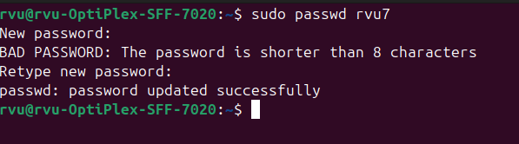

3. cat /etc/passwd –displays content of all users present on the system

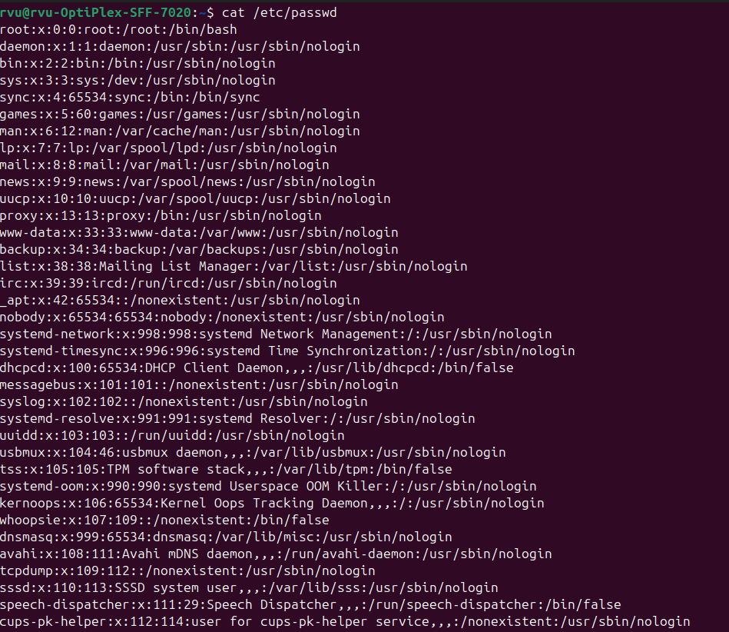

4. sudo deluser username –deletes the user

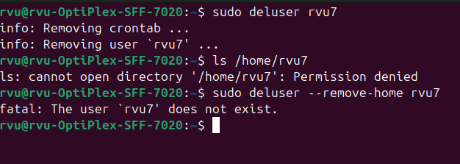

**Lab 5:**

**Aim: Writing Basic Shell scripts**

**Commands used:**

* vim script_name.sh
* nano script_name.sh

**Usage:**

1. vim Backup.sh –copies all .c files into a zipped Backup folder

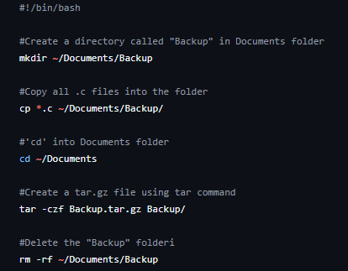

2. nano sysinfo.sh –displays basic information

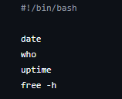

**Lab 6:**

**Aim: Mount and Formatting USB drives**

**Commands used:**

* udisksctl mount –b /dev/sda1
* udisksctl unmount –b /dev/sda1
* df
* sudo mkfs

**Usage:**

1. udisksctl mount –b /dev/sda1

udisksctl unmount –b /dev/sda1

-Mounting and Unmounting a connected pendrive.

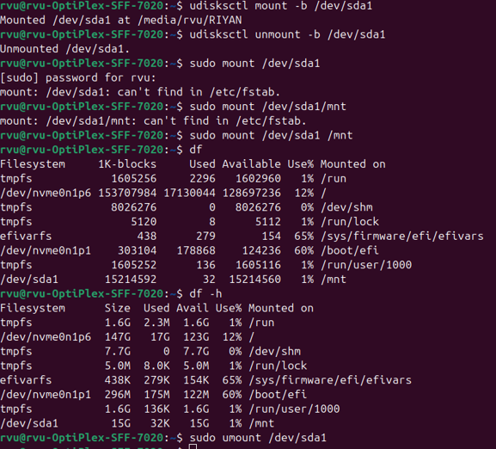

2. sudo mkfs -Formatting the pendrive

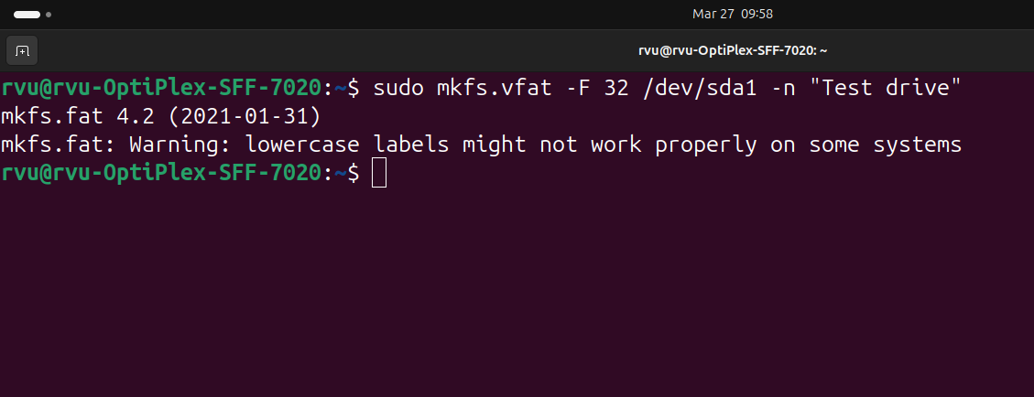

3. Viewing the contents of VirtualDrive

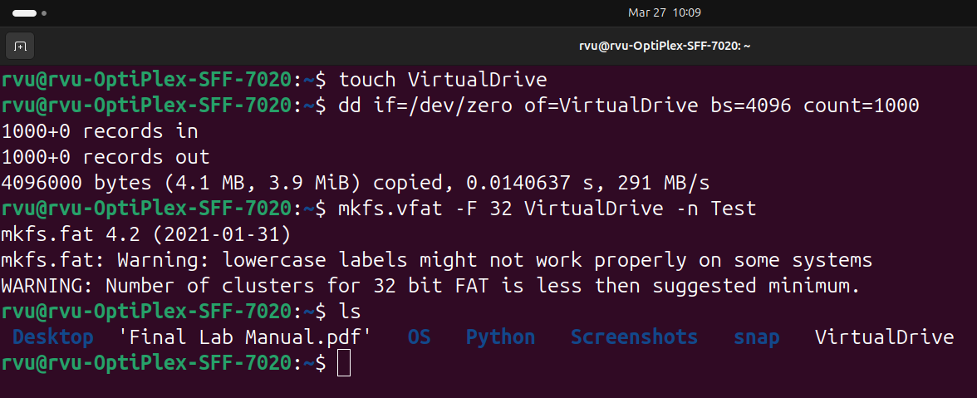

**Lab 7:**

**Aim: Backing Up and Compressing Files**

**Commands used:**

* tar
* gzip

**Usage:**

1. tar –cvf –creates an archive of all .sh files

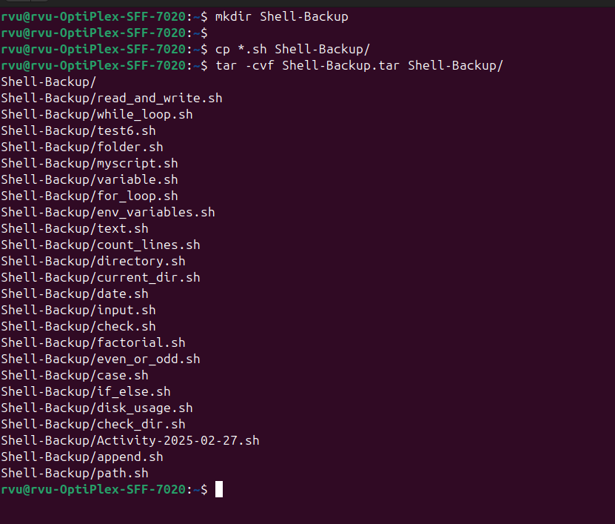

2.gzip filename.txt –compresses the file

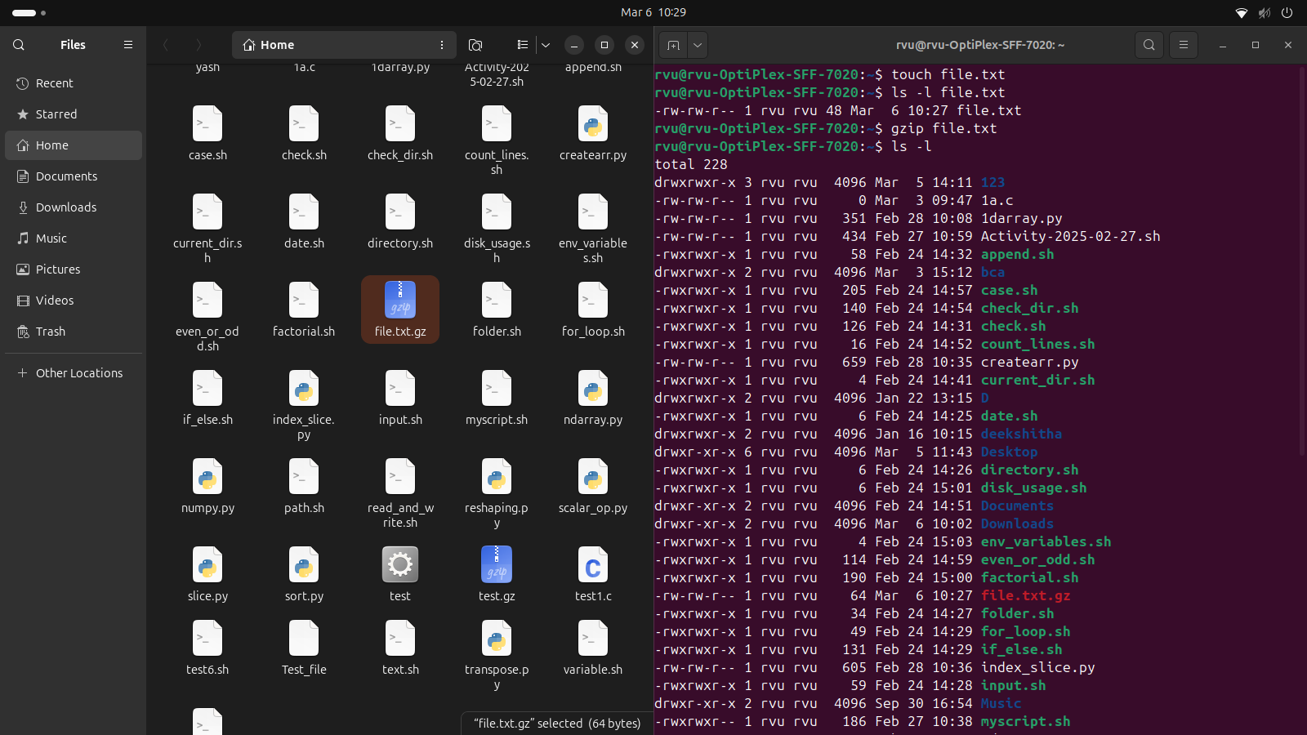

**Lab 8:**

**Aim: Managing User and Group Permissions and Communication Utilities**

**Commands used:**

* chmod

**Usage:**

This Bash script performs a series of file operations and process management tasks.

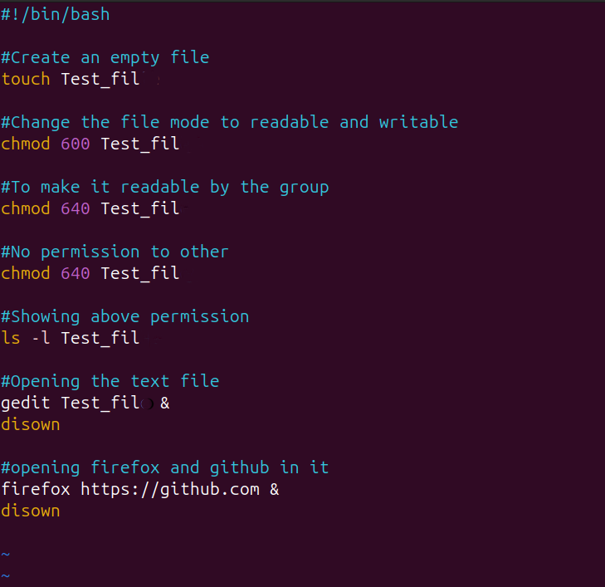

**Lab 9:**

**Aim: Process Management**

**Commands used:**

* ps aux
* top
* pidof
* pkill

**Usage:**

1. ps aux –displays detailed information of all running processes

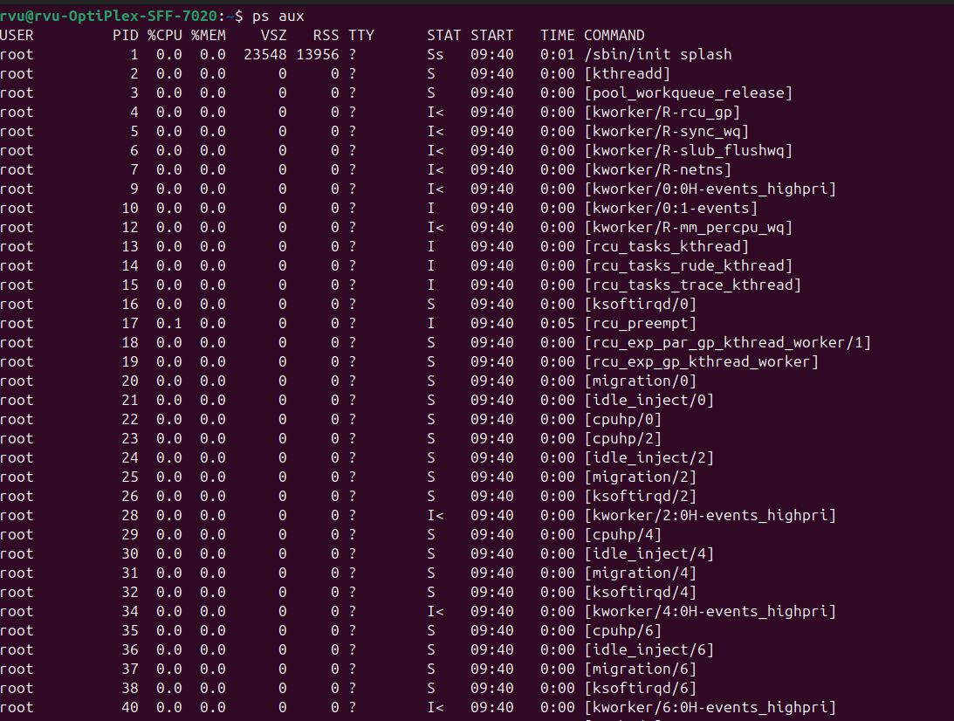

2. top –provides real-time, dynamic view of system’s processes & resource usage

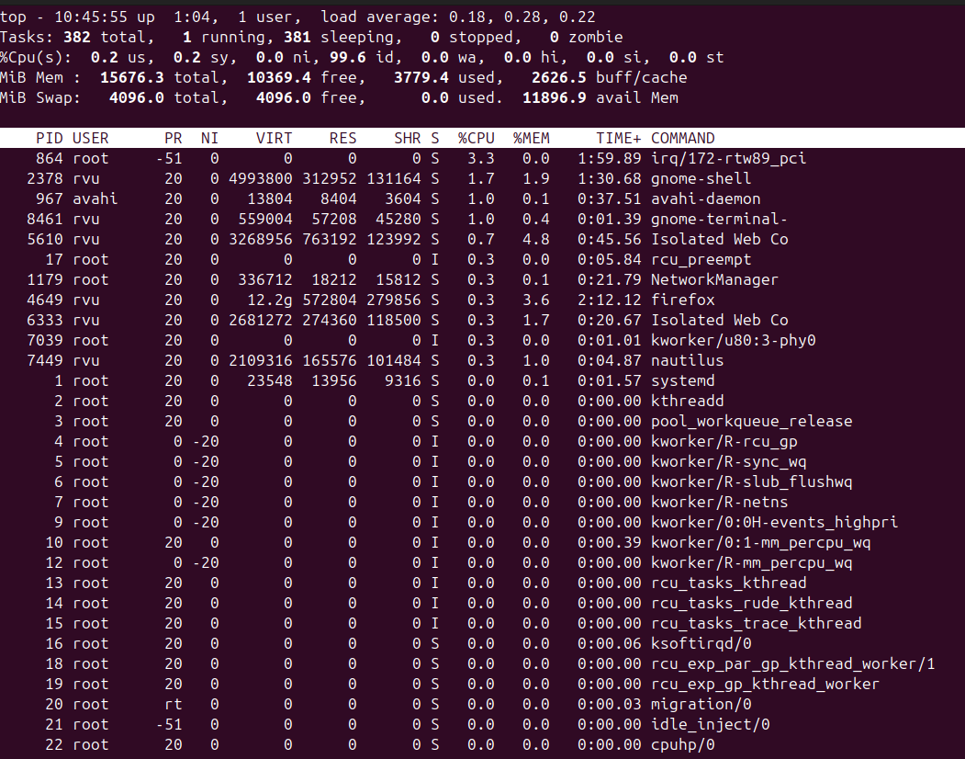

3. pidof –find the process ID

pkill –kill processes by name

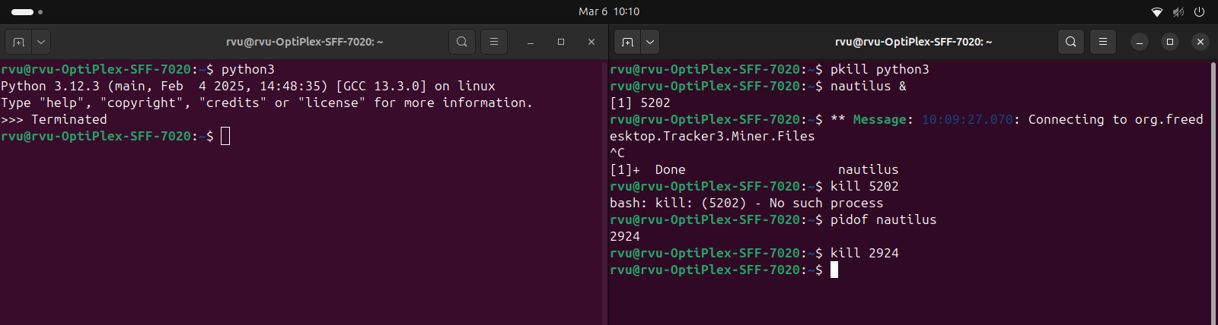

**Lab 10:**

**Aim: Disk Space Management**

**Commands used:**

* df -h

**Usage:**

df -h –shows how much disk space is used and available

